Harry Huang 12/06/20

AMS 333 Fall 2020

# Modeling an Epidemic

Influenza, or “the flu”, comes in many strains with varying lethalities. Despite differences, they can be reasonably modeled the same ways. One reasonable model of the flu is that of an SIR disease model, where individuals in a population can be in one of three states:  
S-susceptible, I-infective, or R-recovered. Susceptible individuals can be infected. Infective individuals have been infected and can in turn infect others. Recovered individuals are no longer infected and are considered immune.

Transition between the S and I states is calculated by a rate equation that multiplies the number of susceptible and number of infective by β, an infectivity constant that describes the likelihood that a single infective individual will infect a susceptible individual. Transition between the I and R states is calculated by multiply the number of infective individuals by γ, a recovery constant that describes the rate of recovery.

Let us assume a recovery rate (γ) of 5% per individual per day, and an infection rate (β) of 5x10-7 per individual per day. The units for beta is “per individuals per day” or (individuals-1 day-1) because the transition equation between S and I is (beta*S*I) in units (individuals/day) and S*I has units (individuals2), so beta must be in units (individuals-1 day-1) to balance the units into the final unit measure. The current infection rate is reasonable because if a disease were to persist/survive in nature, the infection rate has to be high enough to ensure the disease propagates through time and the current rate of 5x10-7 is high enough to do that.

The SIR model can be implemented with the Forward Euler method of calculating changes in the number of individuals in each state by the current number of individuals. With additional parameters of a time step of 0.001 days, an initial population of one million individuals total, and with an initial 10 of that one million in the infective state, the SIR model can be simulated.

**MATLAB Code for figures 1-7**

%Parameters

beta_gamma_combos= {{5e-7 0.05} {5e-7 0.05} {10*5e-7 0.05} {10*5e-7 0.05*10} {0.1*5e-7 0.05} {5e-7 0.05*10}};

death_rate= 0.05;

dt= 0.001; %days

maxT= 365; %days

steps= maxT/dt;

time= 0:dt:maxT;

%Initialize or reset category arrays

N= 1e6;

sus= zeros(size(time));

sus(1)= (1e6-10)/N; %All 1 million, except 10, are initial susceptible

infective= zeros(size(time));

infective(1)= 10/N; %Only 10 are initially infective

recovered= zeros(size(time));

deaths= zeros(size(time)); %total deaths over time

for i2=1:6

beta= beta_gamma_combos{i2}{1}; %infection rate

gamma= beta_gamma_combos{i2}{2}; %recovery rate

%Forward Euler

for i=1:steps

sus(i+1)= sus(i)-dt*(beta*N*sus(i)*infective(i));

infective(i+1)= infective(i)+ dt*(beta*N*sus(i)-gamma)*infective(i);

if i2==2 %if the model incorporates deaths

infective(i+1)= infective(i)+ dt*(beta*N*sus(i)-gamma-death_rate)*infective(i);

deaths(i+1)= deaths(i)+dt*death_rate*infective(i);

normal_deaths= deaths(length(deaths)); %This variable is exported for later use

end

recovered(i+1)= recovered(i)+dt*(gamma*infective(i));

end

if i2==1

name= 'original parameters';

elseif i2==2

name= 'original parameters incorporating deaths';

elseif i2==3

name= '10x beta';

elseif i2==4

name= '10x beta & 10x gamma';

elseif i2==5

name= 'one tenth beta';

elseif i2==6

name= '10x gamma';

end

f= figure('Name',name);

plot(time, sus)

hold on

plot(time, infective)

plot(time, recovered)

if i2==2

plot(time, deaths)

end

hold off

title(name+ " over 1 year")

xlabel('Time(days)')

ylabel('Fraction of total population')

legend('Susceptible','Infective','Recovered')

if i2==2

legend('Susceptible','Infective','Recovered','Deaths')

end

saveas(f,name,'png')

if i2==1

f=figure('Name', 'S vs I dynamics');

plot(sus,infective)

hold on

plot(sus,infective==0,':k');

xline(gamma/(beta*N),':k');

title ('S vs I dynamics')

xlabel('fraction susceptible')

ylabel ('fraction infective')

saveas(f,'S vs I dynamics','png')

end

end

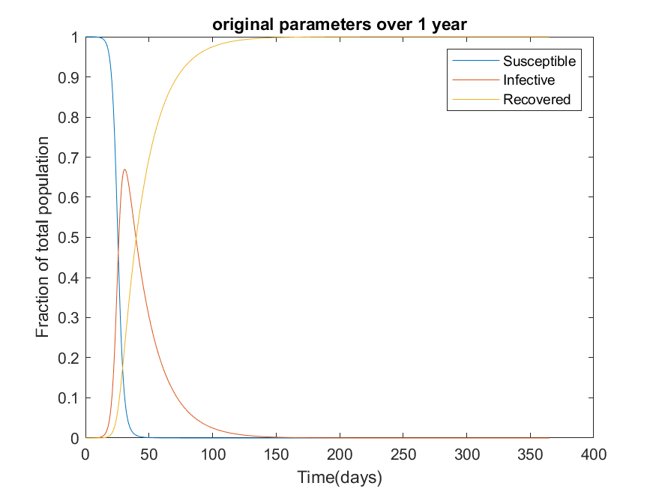  
Figure 1. SIR model of 1 million individuals with 10 initially infected with beta= 5x10-7, recovery rate of 5% per individual per day, and zero death rate

Figure 2. Susceptible vs infective population dynamics in SIR model of 1 million individuals with 10 initially infected with beta= 5x10-7, recovery of 5%, and no deaths. Dotted vertical line represents infective null-cline. Dotted vertical line on x-axis represents susceptible null-cline. Blue line represents susceptible vs infective plotted in terms of fractional populations.

Modeling with the original beta and gamma parameters, without death, the epidemic starts around 20 days and ends around 150 days, lasting for a grand total of 130 days. By the end of the epidemic, virtually everyone has been infected and nobody has avoided the disease. Most of the susceptible population gets infected before 50 days. The drop in susceptible individuals is sigmodal, meaning the number of daily infected initially exponentially rises, plateaus, then starts decreasing exponentially at the inflection around 30 days. This is due to the nature of how people infect other people because when the number of infective outnumber the susceptible, there are not enough susceptible people for the infective to infect at the highest theoretical rate. In other words, the infective interactions are not saturated. Shortly after the susceptible population inflection, the infective population reaches a peak around 40 days. It is at this same peak that the number of daily recovery is highest because daily recovered is modeled as a multiple of number of infective, more infective means more recovered. The infective population curve is a bell curve that only has a real presence up to 150 days. After 150 days, virtually all people are recovered (figure 1).

If a disease is lethal, it may lead to deaths. The SIR model can be adjusted to incorporate disease-related deaths.

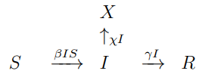

Where χ represents the rate of death due to disease and X represents dead individuals. If χ is non-zero, the total living population (S+I+R) of the model decreases over time.

Figure 3. SIR model of 1 million individuals with 10 initially infected with beta= 5x10-7, recovery rate of 5%, and incorporating 5% per individual per day death rate. The Recovered curve and Deaths curve overlap entirely and are both represented by the purple Deaths curve.

The epidemic can actually be thought of as two phases, one phase before the infective peak (before virtually all susceptible individuals are infected) and one phase after. The phase before the infective peak is an “**infection phase**”, during which susceptible individuals are being infected faster than they recover, whereas the phase after the peak is the “**recovery phase**”, during which individuals are recovering faster than they get infected (figure 1).

Modeling with the original beta and gamma parameters, but with χ= 5% deaths per individual per day, the model tells a very different story. The epidemic lasts from day 12 to day 80. The length of the epidemic is shorter because the recovery phase is shorter. The recovery phase is shorter because the rate of which individuals transition out of the infective phase is doubled compared to the original model due to the addition of a 5% death rate alongside the 5% recovery rate. The susceptible and infective population curves behave similar to the way they did without death, but the recovered population curve plateaus at 0.5 (figure 1,2). The recovered and deaths curve match completely because the rate of recovery per day was exactly the same as the rate of deaths per day. As a result, since virtually everyone got infected, half the people recovered, and half the people died. Out of the 1 million total, about 500,000 individuals died by the end of the year. The other ~500,000 recovered.

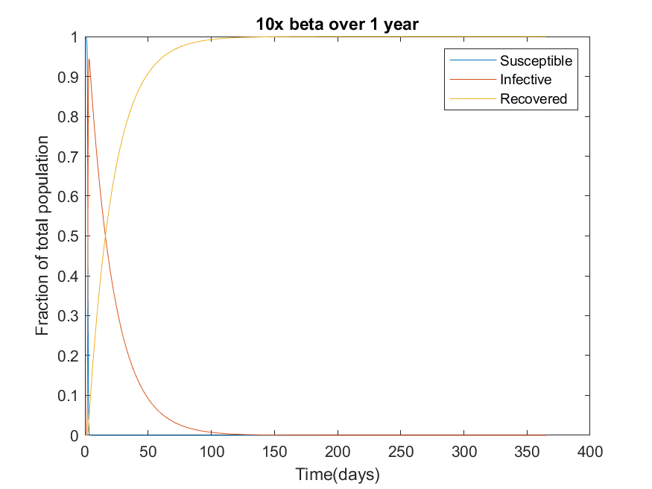  
Figure 4. SIR model of 1 million individuals with 10 initially infected with beta= 5x10-6, recovery rate of 5% per individual per day, and 0 death rate

If beta is increased by a factor of 10 (beta= 5x10-6), the epidemic is shorter in duration. It starts almost immediately at day 3 and is virtually over by day 120. At the end of the year, everybody has been infected and is recovered. The infection phase is much shorter compared to the original model, but the recovery phase is the same length in both (figure 1,4). In layman’s terms, this means that the disease spreads faster, but the recovery rate remains the same.

Figure 5. SIR model of 1 million individuals with 10 initially infected with beta= 5x10-6, recovery rate of 50% per individual per day, and 0 death rate

Now if both beta and gamma are increased by a factor of 10 (beta= 5x10-6, gamma= 0.5 per individual per day, respectively), the epidemic is much, much shorter than in the original model (figures 1,5). At the end of the year, everybody has been infected and is recovered. It starts almost immediately at day 3 and is over around day 20. Both the infection phase and the recovery phase, as define previously, are shorter than in the original. The infection phase is shorter because beta, the infection rate constant, is higher, meaning a faster rate of spread. The recovery phase is shorter because gamma, the recovery rate constant, is higher, meaning people more people recovery from the disease every day, comparatively. Everyone gets infected faster and everyone gets better faster.

Figure 6. SIR model of 1 million individuals with 10 initially infected with beta= 5x10-8, recovery rate of 5% per individual per day, and 0 death rate

Setting beta to 1/10 it’s original value and reverting the recovery to 5% per individual per day, no epidemic occurs. After one year, almost everybody has avoided getting infected. At first glance, it looks like no infection is occurring, but this is not the case. Infections are still occurring throughout the year. However, the infection rate is so low that the recovery rate outpaces it. More people are recovering every day than getting infected, so the infective never accumulate. However, it is important to keep the distinction that the disease persists in this model and the number of total infected is very, very slowly rising (figure 6). Eventually, after a very, very long time, everyone will have contracted the disease and recovered. Such a model’s accuracy to the real world is questionable as a disease like this could possibly die off if it doesn’t manage to infect another individual before being eradicated from the host. However, such diseases do exist in the form of chronic diseases like herpes that are only active sometimes and individuals can “recover” from them before spreading them, although the definition of recovery is now in contention.

Figure 7. SIR model of 1 million individuals with 10 initially infected with beta= 5x10-7, recovery rate of 50% per individual per day, and 0 death rate

Setting the recovery rate to 10x it’s original value (gamma= 0.50 per individual per day) and using the original infection rate (beta= 5x10-7), no epidemic occurs (figure 7). The phenomenon is the exact same as observed in the 1/10th beta model previously, where the rate of recovery outpaces the rate of infection and infectives do not accumulate (figure 6). Following the same logic, the disease persists and the total number of infections and subsequent recoveries will slowly rise to encapsulate 100% of the population. Eventually, everyone will have the disease.

In cases where the infection rate outpaces the recovery rate (figure 1-5), the best possible course of action would be to reduce the infection rate by taking deliberate measures. Such deliberate measures include social-distancing or wearing a mask because these elements reduce contact between individuals and therefore reduce the likelihood/rate of the disease spreading.

In cases where the recovery rate outpaces the infection rate (figure 6,7), the solution to eradicate the disease seems simple: let it die out. However, in real life, diseases with such characteristics have persisted because they have special traits that allow them to persist. Herpes, for example, is a permanent disease that stays with individuals for their lifetimes. Preventing transmission of diseases like herpes, that have special traits to compensate for their recovery rate>infection rate phenomenon, is best done by identifying who has the disease and avoiding them during the times they are infective or avoiding sharing any hygiene products. Simple public health programs, such as sex-education or contraceptive dispensation, may increase awareness and promote behaviors that reduce infection rates. However, until infection rates reach 0 and all infective persons have recovered, no disease will be eradicated.

# Quarantine and Vaccination

To combat epidemics, two measures are obvious: quarantine and vaccination. Quarantine involves separation of infective individuals from susceptible individuals, preventing contact and thus reducing the likelihood of transmission. Vaccination involves giving otherwise susceptible individuals a treatment that gives them immunity, or at the very least resistance to being infected. Due to difficulties in distribution and implementation, vaccinations are not always taken by all individuals and a population (not an individual) typically only experiences resistance to a disease rather than full immunity. This resistance due to vaccination that a population experiences is not because all individuals are homogenously less likely to contract the virus, but that the heterogenous few that did not take the vaccine are less likely to come into contact with an infective individual in a phenomenon known as herd-immunity.

To implement quarantine of infective individuals measures into a model, we can add a quarantine adjuster 1-*q* alongside beta when calculating the rate of transition between susceptible and infective, where *q* represents the effectiveness of quarantine. In other words, by modifying beta, we can simulate a quarantine parameter. We do not simply move susceptible individuals to recovered to simulate quarantine because quarantine individuals are not immune and it is unrealistic to suggest that quarantining individuals do not come into contact with infective individuals over the course of an endemic. The quarantine schematic is:

As *x*, the effectiveness of quarantine, gets stronger, the rate of infection decreases. Note that the initial number of individuals in any of the states has not been changed from original parameters, but rather the only change is in the rate of transition from susceptible 🡪 infective

**MATLAB code for figures 8-13, modeling quarantine and vaccination**

beta= 5e-7; %infection rate

gamma= 0.05; %recovery rate

death_rate= 0.05;

dt= 0.001; %days

maxT= 365; %days

steps= maxT/dt;

time= 0:dt:maxT;

%Initialize category arrays

N= 1e6;

sus= zeros(size(time));

infective= zeros(size(time));

recovered= zeros(size(time));

deaths= zeros(size(time)); %total deaths over time

for i2=1:2 %If i2=1, quarantine iteration. If i2=2, vaccination iteration

x=0; %initial threshold multiplier, resets between model iterations

%Initial run to establish baseline deaths

if i2==1 %quarantine model

name= 'Quarantine Model';

%Initial abundances

sus(1)= (1e6-10)/N; %All 1 million, except 10, are initial susceptible

infective(1)= 10/N; %Only 10 are initially infective

%Forward Euler

for i=1:steps

sus(i+1)= sus(i)-dt*((1-x)*beta*N*sus(i)*infective(i));

infective(i+1)= infective(i)+ dt*((1-x)*beta*N*sus(i)-gamma-death_rate)*infective(i);

recovered(i+1)= recovered(i)+dt*(gamma*infective(i));

deaths(i+1)= deaths(i)+dt*death_rate*infective(i);

normal_deaths= deaths(length(deaths));

end

elseif i2==2 %pre-emptive vaccination model

name= 'Pre-emptive Vaccination Model';

%Initial abundances

sus(1)= (1e6-(x*1e6)-10)/N; %All 1 million, except x proportion of vaccinated and 10 infective, are initial susceptible

infective(1)= 10/N; %Only 10 are initially infective

recovered(1)= x*1e6; %Initial number of vaccinated individuals

%Forward Euler

for i=1:steps

sus(i+1)= sus(i)-dt*(beta*N*sus(i)*infective(i));

infective(i+1)= infective(i)+ dt*(beta*N*sus(i)-gamma-death_rate)*infective(i);

recovered(i+1)= recovered(i)+dt*(gamma*infective(i));

deaths(i+1)= deaths(i)+dt*death_rate*infective(i);

normal_deaths= deaths(length(deaths));

end

end

thresholds= {0.5*normal_deaths 0.1*normal_deaths 0.01*normal_deaths};

%Threshold checking loops

%Check for 50 threshold

while deaths(length(deaths))>thresholds{1}

x=x+0.001;

if i2==1 %quarantine model

%Initial abundances

sus(1)= (1e6-10)/N; %All 1 million, except 10, are initial susceptible

infective(1)= 10/N; %Only 10 are initially infective

%Forward Euler

for i=1:steps

sus(i+1)= sus(i)-dt*((1-x)*beta*N*sus(i)*infective(i));

infective(i+1)= infective(i)+ dt*((1-x)*beta*N*sus(i)-gamma-death_rate)*infective(i);

recovered(i+1)= recovered(i)+dt*(gamma*infective(i));

deaths(i+1)= deaths(i)+dt*death_rate*infective(i);

end

elseif i2==2 %pre-emptive vaccination model

%Initial abundances

sus(1)= (1e6-(x*1e6)-10)/N; %All 1 million, except x proportion of vaccinated and 10 infective, are initial susceptible

infective(1)= 10/N; %Only 10 are initially infective

recovered(1)= x*1e6/N; %Initial number of vaccinated individuals

%Forward Euler

for i=1:steps

sus(i+1)= sus(i)-dt*(beta*N*sus(i)*infective(i));

infective(i+1)= infective(i)+ dt*(beta*N*sus(i)-gamma-death_rate)*infective(i);

recovered(i+1)= recovered(i)+dt*(gamma*infective(i));

deaths(i+1)= deaths(i)+dt*death_rate*infective(i);

end

end

end

x1=x; %effectiveness multiplier to reach 50 percent death reduction

reduction= ' 50%';

f= figure('Name',strcat(name,reduction, ' death reduction over 1 year'));

plot(time, sus)

hold on

plot(time, infective)

plot(time, recovered)

plot(time, deaths)

hold off

title(strcat(name,reduction, ' death reduction over 1 year'))

xlabel('Time(days)')

ylabel('Fraction of total population')

legend('Susceptible','Infective','Recovered','Deaths')

saveas(f,strcat(name,reduction),'png')

%Check for 90 threshold

while deaths(length(deaths))>thresholds{2}

x=x+0.01;

if i2==1 %quarantine model

%Initial abundances

sus(1)= (1e6-10)/N; %All 1 million, except 10, are initial susceptible

infective(1)= 10/N; %Only 10 are initially infective

%Forward Euler

for i=1:steps

sus(i+1)= sus(i)-dt*((1-x)*beta*N*sus(i)*infective(i));

infective(i+1)= infective(i)+ dt*((1-x)*beta*N*sus(i)-gamma-death_rate)*infective(i);

recovered(i+1)= recovered(i)+dt*(gamma*infective(i));

deaths(i+1)= deaths(i)+dt*death_rate*infective(i);

end

elseif i2==2 %pre-emptive vaccination model

%Initial abundances

sus(1)= (1e6-(x*1e6)-10)/N; %All 1 million, except x proportion of vaccinated and 10 infective, are initial susceptible

infective(1)= 10/N; %Only 10 are initially infective

recovered(1)= x*1e6/N; %Initial number of vaccinated individuals

%Forward Euler

for i=1:steps

sus(i+1)= sus(i)-dt*(beta*N*sus(i)*infective(i));

infective(i+1)= infective(i)+ dt*(beta*N*sus(i)-gamma-death_rate)*infective(i);

recovered(i+1)= recovered(i)+dt*(gamma*infective(i));

deaths(i+1)= deaths(i)+dt*death_rate*infective(i);

end

end

end

x2=x; %effectiveness multiplier to reach 90 percent death reduction

reduction= ' 90%';

f= figure('Name',strcat(name,reduction, ' death reduction over 1 year'));

plot(time, sus)

hold on

plot(time, infective)

plot(time, recovered)

plot(time, deaths)

hold off

title(strcat(name,reduction, ' death reduction over 1 year'))

xlabel('Time(days)')

ylabel('Fraction of total population')

legend('Susceptible','Infective','Recovered','Deaths')

saveas(f,strcat(name,reduction),'png')

%Check for 99 threshold

while deaths(length(deaths))>thresholds{3}

x=x+0.01;

if i2==1 %quarantine model

%Initial abundances

sus(1)= (1e6-10)/N; %All 1 million, except 10, are initial susceptible

infective(1)= 10/N; %Only 10 are initially infective

%Forward Euler

for i=1:steps

sus(i+1)= sus(i)-dt*((1-x)*beta*N*sus(i)*infective(i));

infective(i+1)= infective(i)+ dt*((1-x)*beta*N*sus(i)-gamma-death_rate)*infective(i);

recovered(i+1)= recovered(i)+dt*(gamma*infective(i));

deaths(i+1)= deaths(i)+dt*death_rate*infective(i);

end

elseif i2==2 %pre-emptive vaccination model

%Initial abundances

sus(1)= (1e6-(x*1e6)-10)/N; %All 1 million, except x proportion of vaccinated and 10 infective, are initial susceptible

infective(1)= 10/N; %Only 10 are initially infective

recovered(1)= x*1e6/N; %Initial number of vaccinated individuals

%Forward Euler

for i=1:steps

sus(i+1)= sus(i)-dt*(beta*N*sus(i)*infective(i));

infective(i+1)= infective(i)+ dt*(beta*N*sus(i)-gamma-death_rate)*infective(i);

recovered(i+1)= recovered(i)+dt*(gamma*infective(i));

deaths(i+1)= deaths(i)+dt*death_rate*infective(i);

end

end

end

x3=x; %effectiveness multiplier to reach 99 percent death reduction

reduction= ' 99%';

f= figure('Name',strcat(name,reduction, ' death reduction over 1 year'));

plot(time, sus)

hold on

plot(time, infective)

plot(time, recovered)

plot(time, deaths)

hold off

title(strcat(name,reduction, ' death reduction over 1 year'))

xlabel('Time(days)')

ylabel('Fraction of total population')

legend('Susceptible','Infective','Recovered','Deaths')

saveas(f,strcat(name,reduction),'png')

end

Figure 8. SIR model of a lethal disease incorporating quarantine measures to reduce deaths by 50% relative to no quarantine. 1 million total initial individuals with 10 initially infected, beta= 5x10-7, recovery rate of 5% per individual per day, death rate of 5% per individual per day, and quarantine effectiveness of 72.1%.

Figure 9. SIR model of a lethal disease incorporating quarantine measures to reduce deaths by 90% relative to no quarantine. 1 million total initial individuals with 10 initially infected, beta= 5x10-7, recovery rate of 5% per individual per day, death rate of 5% per individual per day, and quarantine effectiveness of 76.1%.

Figure 10. SIR model of a lethal disease incorporating quarantine measures to reduce deaths to 99% relative to no quarantine. 1 million total initial individuals with 10 initially infected, beta= 5x10-7, recovery rate of 5% per individual per day, death rate of 5% per individual per day, and quarantine effectiveness of 78.1%.

Using original population and rate parameters, quarantine needs to be 72.1% effective to reduce deaths by 50% relative to no quarantine (figure 8). Quarantine needs to be 76.1% effective to reduce deaths by 90% (figure 9). Lastly, quarantine needs to be 78.1% effective to reduce deaths by 99% (figure 10). Quarantine is a feasible solution in this case because it only requires about 80% quarantine effectiveness to reduce virtually all death. In essence, by reducing the transmission rate by about 80% by isolation of infective individuals, we can stop the modeled disease. Of course, this feasibility will vary with diseases because it quarantine effectiveness is dependent on the natural transmission rate of the virus in question. In the real-world, quarantine may not be a feasible solution due to culture and the antagonistic nature of quarantine to daily activities.

To implement pre-emptive vaccination measures to the model, some proportion of susceptible individuals are initially moved to the recovered state without having to go through the infective state. This means that the initial number of people in the susceptible state is lower and the exact number of individuals removed from the susceptible state is added to the initial number of people in the recovered state. For the sake of this analysis, the total number of otherwise initially susceptible is N (total vaccinated and unvaccinated susceptible individuals), the vaccinated proportion is *p*, and the unvaccinated proportion is *q*. The vaccination schematic is:

Notice how the transition rates between S, I, X, and R resemble that of the original SIR model of a lethal disease. However, the main difference is that the initial values of S and R are dictated by vaccination proportions *p* and *q*.

Figure 11. SIR model of a lethal disease incorporating pre-emptive vaccination measures to reduce deaths to 50% relative to no vaccination. 1 million total initial individuals with 10 initially infected, beta= 5x10-7, recovery rate of 5% per individual per day, death rate of 5% per individual per day, and vaccination proportion of 45.9%

Figure 12. SIR model of a lethal disease incorporating pre-emptive vaccination measures to reduce deaths to 90% relative to no vaccination. 1 million total initial individuals with 10 initially infected, beta= 5x10-7, recovery rate of 5% per individual per day, death rate of 5% per individual per day, and vaccination proportion of 74.9%

Figure 13. SIR model of a lethal disease incorporating pre-emptive vaccination measures to reduce deaths to 99% relative to no vaccination. 1 million total initial individuals with 10 initially infected, beta= 5x10-7, recovery rate of 5% per individual per day, death rate of 5% per individual per day, and vaccination proportion of 77.9%

Using original population and rate parameters, pre-emptive vaccination needs to be 45.9% effective to reduce deaths by 50% relative to no pre-emptive vaccination (figure 11). Pre-emptive vaccination needs to be 74.9% effective to reduce deaths by 90% (figure 12). Lastly, pre-emptive vaccination needs to be 77.9% effective to reduce deaths by 99% (figure 13). Pre-emptive vaccination is feasible because it only requires vaccinating slightly less than half the susceptible population in order to reduce deaths by 50%. Achieving such vaccination rates, even up to the 77.9% required to reduce deaths by 99%, is entirely feasible with public health programs that offer free vaccinations or mandate them. Such programs include free vaccinations for certain diseases like the flu subsidized by the government or school vaccination requirements. In the United States, misinformation has led to small groups being culturally unaccepting of vaccinations, but the prevalence of these groups is not large enough to induce endemic.

The prior method for adding vaccination measures assumes vaccination is available or implemented before an endemic arises. Sometimes, vaccination response is reactionary and a vaccine is synthesized or implemented in response to a current endemic. In such a case, vaccination can be simulated as an “in progress” implementation by adding a transition from the susceptible state directly to the recovered state, with a rate define by some vaccination constant multiplied by the number of susceptible individuals at each time point. Reactionary vaccinations are more difficult to accurately simulate due to real-world dependencies on things like economics, distribution, cultural acceptance, healthcare fluctuations, etc. As such, this paper will focus on simulating pre-emptive vaccinations and will not model reactionary vaccination.